Fruit Classification using CNN Model

Program Code

<https://github.com/anuj05/anuj05/blob/main/pytorch-starter.ipynb>

---For CNN Model

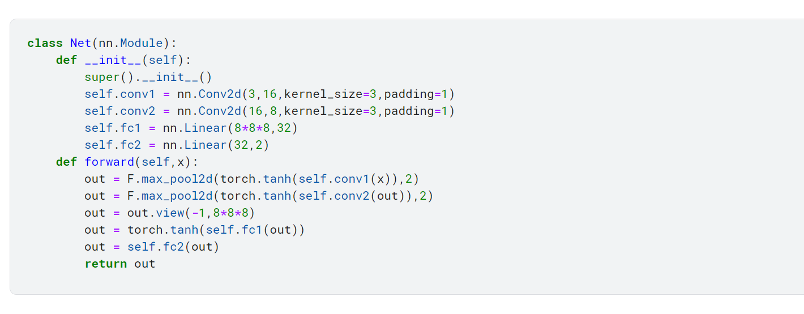

For 5 Epoch

[83.83888226747513]

0.6119626442881396

2022-08-31 04:55:38.335513 Epoch 1, Training Loop 0.6119626442881396

[83.83888226747513, 67.70983991026878]

0.4942324081041517

2022-08-31 04:56:45.699030 Epoch 2, Training Loop 0.4942324081041517

[83.83888226747513, 67.70983991026878, 63.18847322463989]

0.46122973156671454

2022-08-31 04:57:53.763484 Epoch 3, Training Loop 0.46122973156671454

[83.83888226747513, 67.70983991026878, 63.18847322463989, 59.121677339076996]

0.43154509006625547

2022-08-31 04:59:00.824417 Epoch 4, Training Loop 0.43154509006625547

[83.83888226747513, 67.70983991026878, 63.18847322463989, 59.121677339076996, 54.445798486471176]

0.3974145874924903

2022-08-31 05:00:09.174905 Epoch 5, Training Loop 0.3974145874924903

print(acc_)

[1.6340866707039636, 2.0233395940908547, 2.1681169524852173, 2.317254959027501, 2.5162639507260067]

print(loss)

[83.83888226747513, 67.70983991026878, 63.18847322463989, 59.121677339076996, 54.445798486471176]

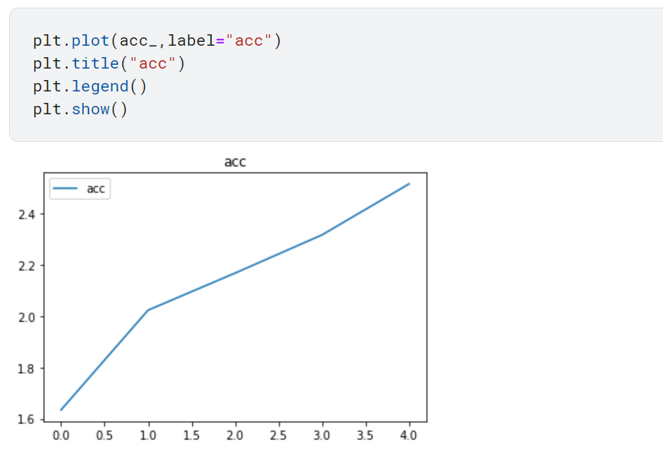

**Loss**

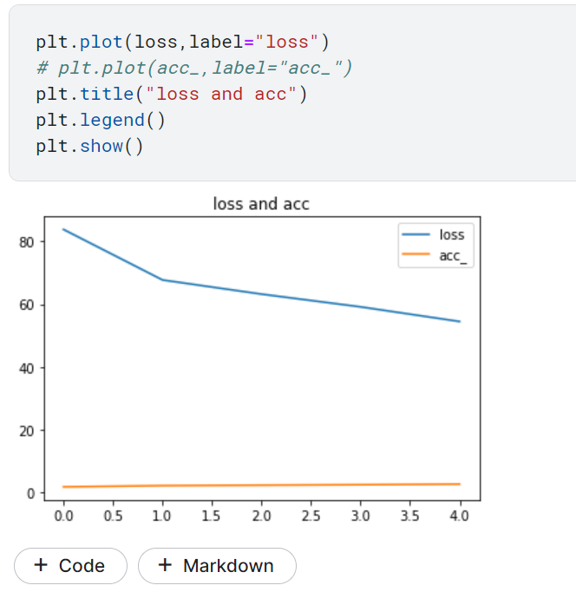

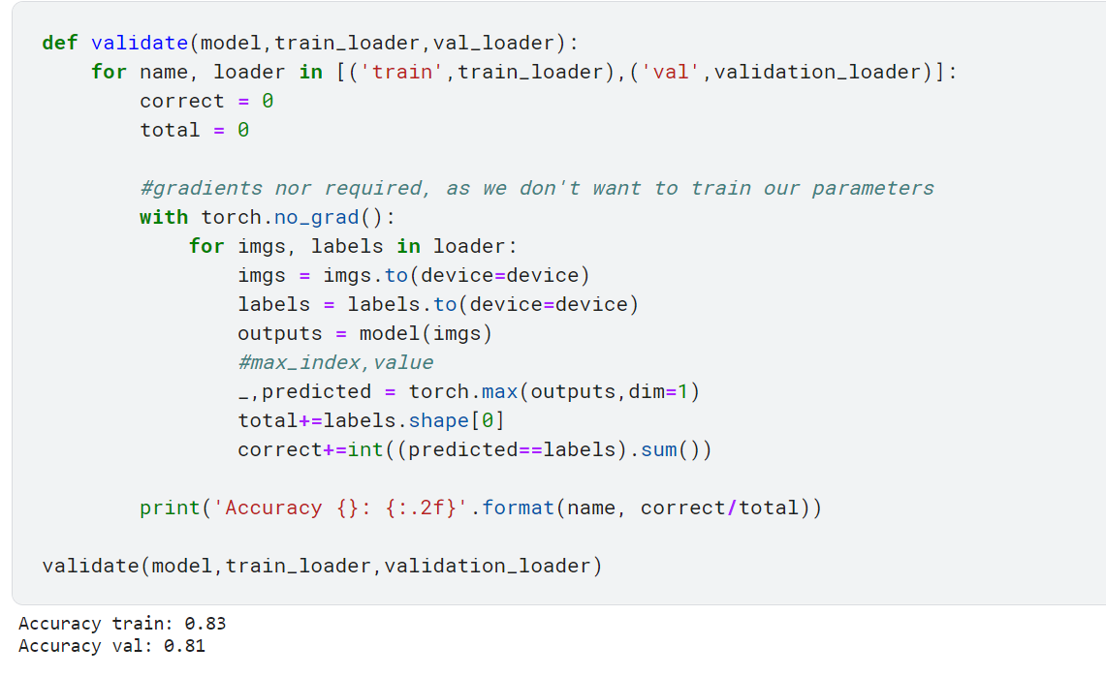

For Epoch 2

[82.52147227525711]

0.6023465129580811

2022-09-02 09:19:31.207234 Epoch 1, Training Loop 0.6023465129580811

[82.52147227525711, 67.0650084912777]

0.48952560942538464

2022-09-02 09:20:36.607189 Epoch 2, Training Loop 0.48952560942538464

print(acc_)

[1.6601739671224638, 2.0427940453898232]

add Codeadd Markdown

[16]:

print(loss)

[82.52147227525711, 67.0650084912777]

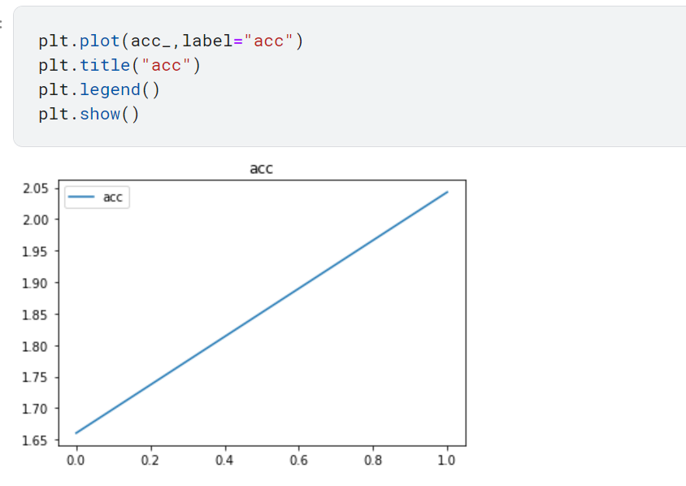

For Epoch 10

[83.18288639187813]

0.6071743532253878

2022-09-02 12:07:29.796080 Epoch 1, Training Loop 0.6071743532253878

[83.18288639187813, 69.02179485559464]

0.5038087215736835

2022-09-02 12:08:31.035388 Epoch 2, Training Loop 0.5038087215736835

[83.18288639187813, 69.02179485559464, 64.89071774482727]

0.4736548740498341

2022-09-02 12:09:32.421174 Epoch 3, Training Loop 0.4736548740498341

[83.18288639187813, 69.02179485559464, 64.89071774482727, 60.94292730093002]

0.44483888540824834

2022-09-02 12:10:34.977796 Epoch 4, Training Loop 0.44483888540824834

[83.18288639187813, 69.02179485559464, 64.89071774482727, 60.94292730093002, 57.14886128902435]

0.4171449729125865

2022-09-02 12:11:36.481034 Epoch 5, Training Loop 0.4171449729125865

[83.18288639187813, 69.02179485559464, 64.89071774482727, 60.94292730093002, 57.14886128902435, 52.544706135988235]

0.38353800099261487

2022-09-02 12:12:38.281011 Epoch 6, Training Loop 0.38353800099261487

[83.18288639187813, 69.02179485559464, 64.89071774482727, 60.94292730093002, 57.14886128902435, 52.544706135988235, 47.92655694484711]

0.34982888280910296

2022-09-02 12:13:39.430034 Epoch 7, Training Loop 0.34982888280910296

[83.18288639187813, 69.02179485559464, 64.89071774482727, 60.94292730093002, 57.14886128902435, 52.544706135988235, 47.92655694484711, 43.30449204146862]

0.3160911827844425

2022-09-02 12:14:40.716071 Epoch 8, Training Loop 0.3160911827844425

[83.18288639187813, 69.02179485559464, 64.89071774482727, 60.94292730093002, 57.14886128902435, 52.544706135988235, 47.92655694484711, 43.30449204146862, 39.70881751179695]

0.289845383297788

2022-09-02 12:15:42.890330 Epoch 9, Training Loop 0.289845383297788

[83.18288639187813, 69.02179485559464, 64.89071774482727, 60.94292730093002, 57.14886128902435, 52.544706135988235, 47.92655694484711, 43.30449204146862, 39.70881751179695, 36.60959795117378]

0.2672233427092977

2022-09-02 12:16:45.155051 Epoch 10, Training Loop 0.2672233427092977

print(acc_)

[1.5709818365475552, 1.9666978732516804, 2.1208684420318638, 2.228769234026134, 2.348945405691246, 2.489290693089461, 2.6414529511122478, 2.855209847077325, 3.007345067482462, 3.2013252498521307]

print(loss)

[87.2066097855568, 69.65991160273552, 64.59618017077446, 61.46890306472778, 58.32404604554176, 55.035757929086685, 51.86539474129677, 47.98246270418167, 45.55513149499893, 42.79477694630623]

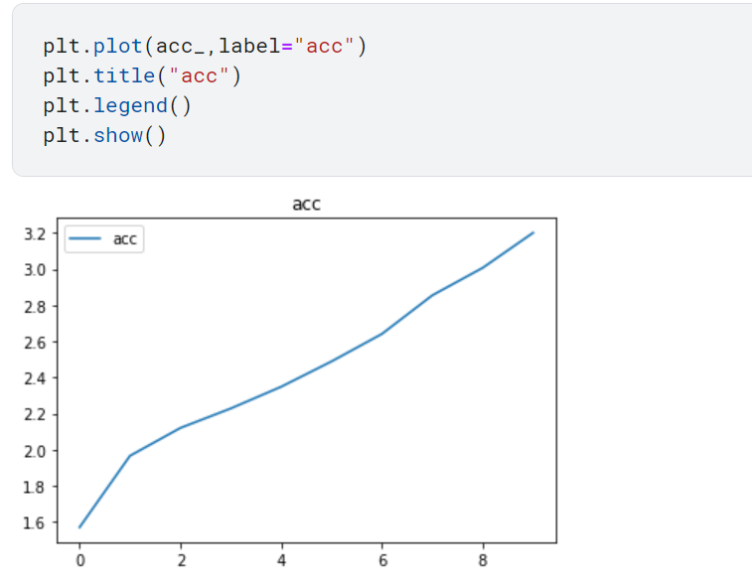

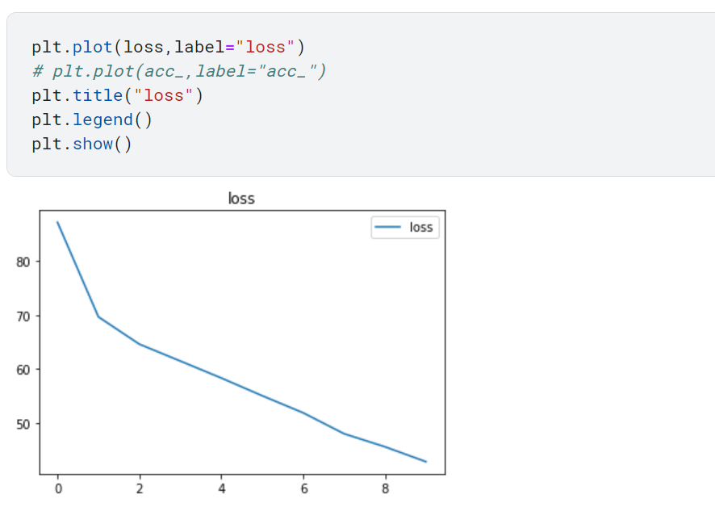

VGG-Image Classification



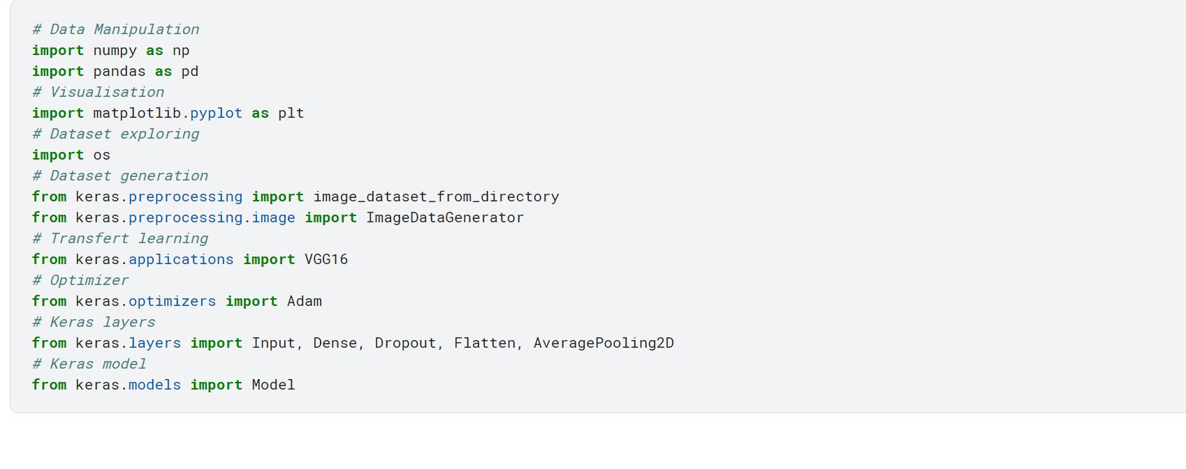

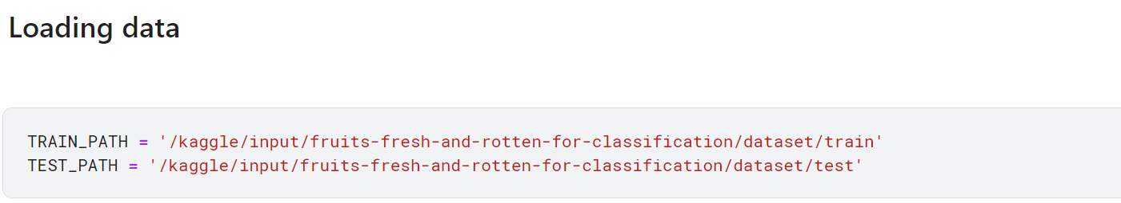

Epoch 1/5

239/239 [==============================] - 249s 1s/step - loss: 0.9273 - accuracy: 0.8251 - val_loss: 0.2199 - val_accuracy: 0.9314

Epoch 2/5

239/239 [==============================] - 202s 844ms/step - loss: 0.3069 - accuracy: 0.9088 - val_loss: 0.1057 - val_accuracy: 0.9657

Epoch 3/5

239/239 [==============================] - 204s 852ms/step - loss: 0.2163 - accuracy: 0.9337 - val_loss: 0.1153 - val_accuracy: 0.9679

Epoch 4/5

239/239 [==============================] - 201s 842ms/step - loss: 0.1593 - accuracy: 0.9492 - val_loss: 0.0682 - val_accuracy: 0.9792

Epoch 5/5

239/239 [==============================] - 202s 845ms/step - loss: 0.1673 - accuracy: 0.9509 - val_loss: 0.0560 - val_accuracy: 0.9816

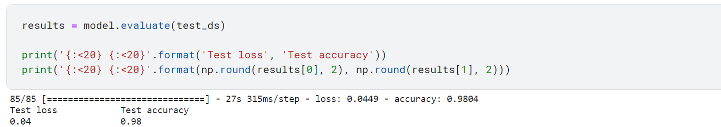

Epoch 1/2

239/239 [==============================] - 293s 1s/step - loss: 0.9168 - accuracy: 0.8149 - val_loss: 0.2470 - val_accuracy: 0.9177

Epoch 2/2

239/239 [==============================] - 234s 981ms/step - loss: 0.2927 - accuracy: 0.9139 - val_loss: 0.1109 - val_accuracy: 0.9624

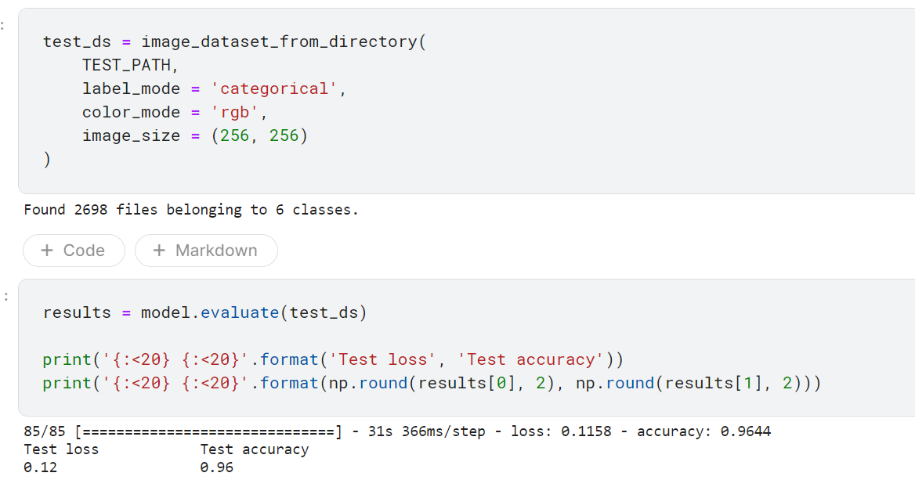

Epoch 1/4

239/239 [==============================] - 225s 940ms/step - loss: 0.8694 - accuracy: 0.8198 - val_loss: 0.1852 - val_accuracy: 0.9394

Epoch 2/4

239/239 [==============================] - 224s 936ms/step - loss: 0.2672 - accuracy: 0.9179 - val_loss: 0.1311 - val_accuracy: 0.9538

Epoch 3/4

239/239 [==============================] - 228s 953ms/step - loss: 0.2159 - accuracy: 0.9312 - val_loss: 0.0908 - val_accuracy: 0.9688

Epoch 4/4

239/239 [==============================] - 225s 943ms/step - loss: 0.1572 - accuracy: 0.9518 - val_loss: 0.0686 - val_accuracy: 0.9746